Effects of Large-Scale Teak Plantation Establishment on Plant Species Composition and Diversity in Kilombero Valley, Tanzania

^{1,2,}*G.D. Ngatena, ²G. Soka, ³P.K.T. Munishi,
¹Tanzania National Parks,
Ministry of Natural Resources and Tourism,
Arusha Tanzania.
²Department of Wildlife Management,
Sokoine University of Agriculture,
Morogoro, Tanzania.
³Department of Ecosystems and Conservation,
Sokoine University of Agriculture,
Morogoro Tanzania
Correspondence: jodengatena90@gmail.com

ABSTRACT
Kilombero Teak Company (KVTC) have cleared more than 7,500 ha of natural miombo woodland since 1992, to establish a teak plantation in Kilombero valley. Currently, less is known about how this large teak plantation supports the previous existed plants species before its establishment. This study, investigated the understory plant species found in teak plantation and made reference on natural remnants around the plantation. The main hypothesis was that, natural remnants around the teak plantation would be richer and diversified in species, than teak plantation. Nested plots of 40 m x 20 m, 20 m x 10 m and 1 m x 1 m were established and used to survey plant species within plantation and natural remnants. Results showed that, natural remnants and plantation were 58% similar in plant species recorded. Natural remnants observed to have a statistically significant higher plant species richness (p = 0.043), families (p = 0.049) and abundance (p = 0.004) but lower plant species diversity (p = 0.01) than the plantation. The higher plant diversity scenario in teak plantation, shows that a plantation can support a variety of non-teak plant species that existed in the valley before its establishment in any favorable condition.
Key words: Natural remnants - plant species richness - plant abundance.

INTRODUCTION
Teak (Tectona grandis) is a large deciduous tree in a flowering family of Lamiaceae (Lowe and Volkaerts 2013). This species is native to Myanmar, India, Thailand, and Laos, covering 23 million ha of natural forest (Kaewkrom et al. 2005, Cañadas et al. 2018). High demand for teak products since the 14th century led to its introduction into plantation even far from its original earthly locality (Hansen et al. 2017). To date, teak tree species has been introduced to about 65 countries in the tropical and subtropical regions (Verhaegen et al. 2010). As a result, teak plantations are estimated to cover about 5.7 million hectares globally (Koonkhunthod et al. 2006).
Global increase in teak cover has been catalyzed with its high growth rate and usefulness in production of furniture, boats, carvings veneer, and turnings in the global market (Palanisamy et al. 2009). Teak plantations have high production proportion, making them crucial in wood market industries (Calvino-Cancela et al. 2012).The tree has high capacity of surviving against pests and diseases while providing a high quantity of wood products at a relatively low cost of production and time, even outside their original locality, as an exotic species (Cubbage et al. 2012).
In Africa, teak tree was introduced for the first time in 19th century to countries like Benin, Cameroon, Cote d’Ivoire, Ghana, Senegal, Sudan, Tanzania, and Togo (Huang et al. 2015). Beginning of the 20th century, the first teak plant was introduced in the garden at Dar es Salaam, Tanzania by planting seeds from India (Malende and Temu 1990). In 1992, Tanzania experienced the first large investment on teak tree plantation in Kilombero valley, Morogoro (Johansson and Isgren 2017). This plantation was established by Kilombero Valley Teak Company (here after KVTC) following high demand for teak wood products in the world market (Bekker and Monteuus 2004).
Development of teak plantation in the valley was in expense of natural vegetation loss in the valley (Hinde et al. 2001a). The activity of establishing the new plantation in the area, involved clearing most of miombo woodland (Bamford et al. 2010). Out of 28,000 ha that KVTC holds, about fifty percent of land was found to be suitable in producing high-quality teak wood required in the world market (Bekker and Monteuus 2004, Bergius et al. 2020). However, a recent study in the valley by Msofe et al. (2019) reported that, the extent of converting the previously natural miombo woodland into exotic teak tree cover by KVTC and other small scale farmers in the valley has reached around 30% to date.
The tradition of converting natural vegetations into exotic plantations is doubted and less supported globally (Hartman et al. 2010). Exotic tree plantations are considered to be large green deserts with just simple structure that can barely support existence of native species to most of activists (Horak et al. 2019, Kremir and Bauhus 2020). Saha (2001) and Harley and Gara (2003) supported that teak tree plantation had lower species, once compared to natural or abandoned old fields. Another study on exotic and monoculture tree plantation of Eucalyptus sp. showed that, plantations had fewer species richness, abundance, and diversity of herbs than native forests (Goded et al. 2019).
However, the contribution of large plantations such as that of teak in lessening the harvesting pressure in natural forests is remarkable (Kanowski et al. 2005, Lindell and Thurston 2013). As a result, there is no doubt that we will need them even in future to come. The focus is now required to understand how the existing plantation affects the previous native plant species before its establishment, so as to improve the management practices (Calvino-Cancela et al. 2012). Studies on the effect of teak plantation establishment on biodiversity at Kilombero Valley have been limited on large mammals (Hinde et al. 2001a, Bonnington et al. 2009) and Anurans (Hinde et al. 2001b).
Less is known about the existed plant species before the development of teak plantation in the valley. The information concern native plants survival in teak plantation is crucial considering the contribution of plants on earth and its living forms (Chittapur and Patil 2017). To a large extent, plant diversity has supported existence of different other species such as bird and insects (Ollerton et al. 2011, Lindell and Thurston 2013). Plants provide essential habitats and foraging materials that in returns enhance pollination and dispersal in plantation ecosystem (Corlett 2016). Seeing the importance of plant in provision of ecosystem and biodiversity restoration, this study was conducted to assess the effectiveness of teak plantation in supporting previous plant species existed in an area before its development using the reference from the retained natural remnants around teak plantation.

MATERIALS AND METHODS

Study site
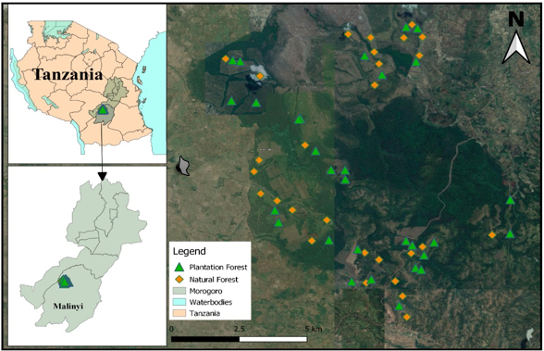
This study was conducted in teak plantations owned by KVTC. This plantation is found at Kilombero Valley located south east of Morogoro region in Tanzania. The Valley is one of the largest East Africa’s seasonal wetlands, centered 80030'16.96" S; 112 36015'51.19" E with an area of about 7,946 km² (Jenkins et al. 2002; Höllermann et al. 2021). The established KVTC plantations have been divided into four blocks, two on each side of the river Kilombero. Those blocks include the Nakafulu block (in Ulanga districts), Mafinji block (in Malinyi districts), Narabungo block, and Ichima block (both in Kilombero district). Each block has several compartments with trees of different ages, surrounded by small to large conserved natural vegetation patches (hereafter natural remnants) (Fig. 1).

Climate
Climate in the valley is normally sub humid tropical with a distinct seasonality (Höllermann et al. 2021). The rainfall is largely unimodal with an annual mean between 1200 and 1400 mm (Jenkins et al. 2002).

Figure 1: Map of a study area

Sampling design
Data was collected in teak plantation compartments of different ages and natural remnants around the plantation. A reconnaissance survey was conducted between October and November 2020 before the commencement of data collection. Mafinji block was purposively selected out of the rest blocks for data collection because, it was observed to possess most of the vegetation types present in other blocks and was easily accessible at a time of survey compared to the rest. Stratified random sampling method was applied and data was collected from 32 plots in teak plantation and 31 in natural remnants respectively (Table 1). The method aimed to capture the difference on habitats variations in plantations and natural remnants observed in the study site as described in Table 2.

Table 1: Proportion of age groups and habitat types surveyed in this study
Vegetation | Age/Habitat | Number of plots | Proportion (%)
Teak plantation | Young age | 11 | 34.38
 | Medium age | 11 | 34.38
 | Old age | 10 | 31.25
Natural remnants | Woodland | 14 | 45.16
 | Forest | 6 | 19.35
 | Grassland | 5 | 16.13
 | Riparian | 4 | 12.90
 | Wetland | 2 | 06.45

Nested plots of 40 m x 20 m were laid 300 m apart and 100 m away from the edges of habitat at each habitat. In each 40 m x 20 m plot, other small subplots of 10 m x 10 m, and 1 m x1 m were established in the center. The large plot (40 m x 20 m) was used for sampling trees while, 10 m x 10 m plot was used to sample shrubs, ferns, and climbers and 1 m x 1 m plot was used in sampling grasses and herbs (Asare et al. 2020).

Data collection
During the survey, the following vegetation information was recorded; plant life form, scientific name, and the number of each individual. All the collected plants were identified in the field by a botanist, with the aid of plant identification field guide books to species level.

Data Analysis
All data collected were coded into a Microsoft Excel spreadsheet. Plant species richness and number of families were computed by counting the number of each plant species and family in each particular habitat. To obtain relative abundance for each plant species, we divided the number of individuals of a particular species by the total number of all individual species combined in such vegetation as follows;
Relative abundance = n / N
where n is the total number of plant individuals of a particular species and N is the total number of plant individuals of all species.

Table 2: Description of major vegetation types found in Kilombero valley teak plantation
Major vegetation | Habitats | Description |  | Management practice
Plantation | Young age | Involved all plantation compartments that range from 0 to 5 years of age. New teak plants emerge from the root stem as buds after the activity of wood teak harvest. | Post-harvest burning, slashing, application of weed killers
 | Medium age | Involved all the compartments aged from 6 to 10 years of age. | Slashing, pruning, and thinning
 | Old age | Involved all plantation compartments aged from 11 to above years. At this age, teaks are ready for harvest. | The pre-harvest slashing of grasses and shrubs
Natural | Woodland | Involved all habitats dominated by trees that are spaced apart and have a full range of understory plant types. | Conserved area
 | Forest | Involved an area of land with at least 0.5 ha of natural trees, with a minimum tree crown cover of 10% and with trees which have the potential or have reached a minimum height of 3 m at maturity | Conserved area
 | Grassland | Involved habitats that are vegetated with herbaceous with less than 10 percent tree and shrub cover. | Conserved area
 | Riparian | Involved all vegetation units along the banks of a river or water stream. | Conserved area
 | Wetland | Involved all vegetated areas of land with flooded soil or with an indication of frequent prolonged flooding. | Conserved area

One-way ANOVA was performed in R-program to compare means of plant species richness, families, and relative abundance within each habitat in a vegetation type. A proportion of each plant life form was generated and illustrated in a histogram for each vegetation by taking the sum of individuals in a particular plant life form in a habitat over the overall sum of all individual plant life form in a particular habitat. Moreover, Sorenson’s similarity coefficient was equally calculated between pairs of habitats as follows:
Similarity = 2a / (2a + b + c)
Where a = number of plant species common to both two habitats; b = number of plant species only belonged to the 1st habitat; c = number of species only belonged to the 2nd habitat. The Bray–Curtis’s dissimilarity index was used in PAST software to measure the extent of similarity in plant species composition between all habitats in this study. Shannon-Weiner Diversity Index (H′), Dominance (D), and Evenness were also computed in PAST software using the formula:
H′ = - [ΣPi * LN(Pi)]
where H′ is the Diversity Index, Pi is the proportion of each species in the sample, and LN (Pi) is the natural logarithm of this proportion.
Dominance (D) was measured by the following formula:
D = 1- [{Σn / n-1}/ {N * (N-1)}]
where n is the total number of plants of a particular species and N is the total number of individual plants of all species.
Evenness Index (J′) was calculated using the ratio of observed diversity to maximum diversity using the equation:
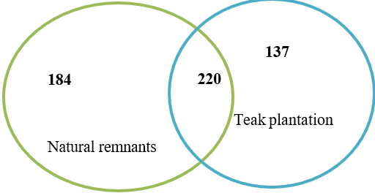
J’ = H’ / H_{max}
where H′ is the Shannon Wiener Diversity index and H_{max} is the natural log of total number of species.
A diversity t-test was used to compare plant species diversity between the two vegetations. The level of significance was set at p < 0.05 for this study.

RESULTS

Plant species composition and relative abundance
A total of 541 plant species belonging to 88 families were recorded in natural and teak plantations habitats. In this study, 184 plant species were restricted to natural remnants, 137 species to teak plantation while 220 plant species were found in both vegetations (Fig 2). Climbers, ferns, grasses, herbs, shrubs, and trees were the major plant life forms recorded in this study. About 98 percent of plant individuals were contributed by trees, shrubs, herbs, and grasses while the remained 2 percent was contributed by climbers and ferns. Among the habitats, natural habitats observed to have a statistically significant higher number of plant species (F₁, ₆₅ = 4.26, p = 0.043), families (F₁, ₆₅ = 4.03, p = 0.049) and relative abundance (F_{1, 65} = 8.17, p = 0.004) than teak plantation.
Figure 2: Number of plant species common and unique to natural and teak plantations

Plant species composition and relative abundance in natural remnants
A total of 404 plant species from 78 plant families were recorded in natural remnants. Woodland had the highest species richness followed by forest, grassland, riparian, and wetland remnants. On the other hand, high numbers of plant families were recorded in woodland, forest, and riparian remnants. The highest relative abundance was observed in woodland followed by forest, grassland, riparian and the least was in wetland remnants (Table 3).
Table 3: Plant species composition and relative abundance in natural habitats
Habitat | Species richness | Number of families | Relative abundance (%)
Woodland | 193 | 50 | 49.7
Forest | 145 | 46 | 16.9
Grassland | 135 | 43 | 11.6
Riparian | 121 | 44 | 11.1
Wetland | 34 | 21 | 10.7
Comparison of plant species composition within the natural habitats revealed a significant variation in plant relative abundance (F₁, 65 = 14.31, p = 0.001) and species richness only. However, among the groups wetland revealed to be significant different (p < 0.05) in mean value from the rest of the groups after Post hoc test. Within the natural remnants, relative abundance ranged between 0.02 and 3.56. Highest plant life forms were recorded from trees, grasses, and shrubs from six plant families in this study.
Such species included Diplorhynchus condylocarpon, Brachystegia bussei, Sorindeia madagascariensis, Margaritaria discoidea, Uapaca nitida, Pseudolachnostylis maprouneifolia, Phragmites australis, Cyperus esculentus, Oplismenus hirtellus, and Pericopsis angolensis (Table 4). Within the natural habitats, trees, shrubs, herbs, and grasses appeared to have higher number of individuals. However, ferns appeared to be restricted to forest remnant while climbers contributed to lower plant individuals in almost all of the natural habitats (Fig 3).

Table 4: Plant species with high relative abundance in natural habitats
SN | Species | Family | Plant form | Relative abundance (%)
1 | Diplorhynchus condylocarpon | Apocynaceae | Tree | 3.6
2 | Brachystegia bussei | Fabaceae | Tree | 3.2
3 | Sorindeia madagascariensis | Anacardiaceae | Tree, shrub | 2.4
4 | Margaritaria discoidea | Phyllanthaceae | Tree, shrub | 2.3
5 | Uapaca nitida | Phyllanthaceae | Tree | 2.2
6 | Pseudolachnostylis maprouneifolia | Phyllanthaceae | Tree | 2.1
7 | Phragmites australis | Poaceae | Grass | 2.1
8 | Cyperus esculentus | Cyperaceae | Grass | 1.9
9 | Oplismenus hirtellus | Poaceae | Grass | 1.7
10 | Pericopsis angolensis | Fabaceae | Tree | 1.6

Figure 3: Distribution of plant life forms in natural remnants

Plant species composition and relative abundance in teak plantation
A total of 357 plant species from 69 families were recorded in teak plantations. The highest number of plant species was recorded in old age plantations followed by young age and the least was in medium age plantations. The highest number of plant families was recorded at a young age followed by old age and medium age habitats. Young age plantation had the highest plant relative abundance that was followed with old age and medium age habitats (Table 5).
There were no significant variations (p > 0.05) in the number of plant species, family or relative abundance across the teak plantations. However, the relative abundance ranged between 0.35 and 3.60 in teak plantations. Trees and shrubs were the dominant plant life forms from Apocynaceae, Fabaceae, Ebenaceae, Nyctaginaceae, and Rutaceae families that together contributed to species with higher proportion. Such species included Harrisonia abyssinica, Diplorhynchus condylocarpon, Brachystegia spiciformis, Diospyros squarrosa, Millettia usaramensis, Diospyros fischeri, Holarrhena pubescens, Commicarpus pedunculosus, Commicarpus pedunculosus, Dalbergia melanoxylon, and Pterocarpus angolensis (Table 6).

Table 5: Plant species composition and relative abundance in teak plantation
Habitats | Species richness | Number of families | Relative abundance (%)
Young age | 190 | 51 | 39.2
Old age | 191 | 52 | 35
Medium age | 171 | 48 | 25.8

Table 6: Plant species with higher relative abundance in teak plantations
SN | Species | Family | Plant form | Relative abundance (%)
1 | Harrisonia abyssinica | Rutaceae | Shrub Herb | 3.6
2 | Diplorhynchus condylocarpon | Apocynaceae | Tree | 3.3
3 | Brachystegia spiciformis | Fabaceae | Tree | 2.7
4 | Diospyros squarrosa | Ebenaceae | Tree | 2.3
5 | Millettia usaramensis | Fabaceae | Tree | 1.6
6 | Diospyros fischeri | Ebenaceae | Shrub Tree | 1.4
7 | Holarrhena pubescens | Apocynaceae | Shrub | 1.4
8 | Commicarpus pedunculosus | Nyctaginaceae | Herb | 1.3
9 | Dalbergia melanoxylon | Fabaceae | Tree | 1.3
10 | Pterocarpus angolensis | Fabaceae | Tree | 1.2

Teak plantations were highly dominated by trees, shrubs and herbs. Ferns recorded the lowest proportion of individuals among all the plant life forms in all of the three plantations, followed by climbers and grasses (Fig. 4). Also, Sorensen similarity index showed that wetland had the lowest similarity index when compared with all other habitats. The lowest value was recorded against the Wetland habitat (0.045). The maximum value (0.457) of plant species similarity was recorded between Medium age and Old age plantations (Table 7). The Bray–Curtis dissimilarity index for plant species composition formed four distinct clusters (Fig. 5). One cluster is comprised of woodland and young age plantation. The second cluster involved forest, riparian habitats that were observed to be similar to old and medium age plantations. The previous was much similar to woodland habitats and young age plantations as compared to grassland and wetland habitats that were less similar to the rest of the habitats

Figure 4: Distribution of plant life forms in teak plantations
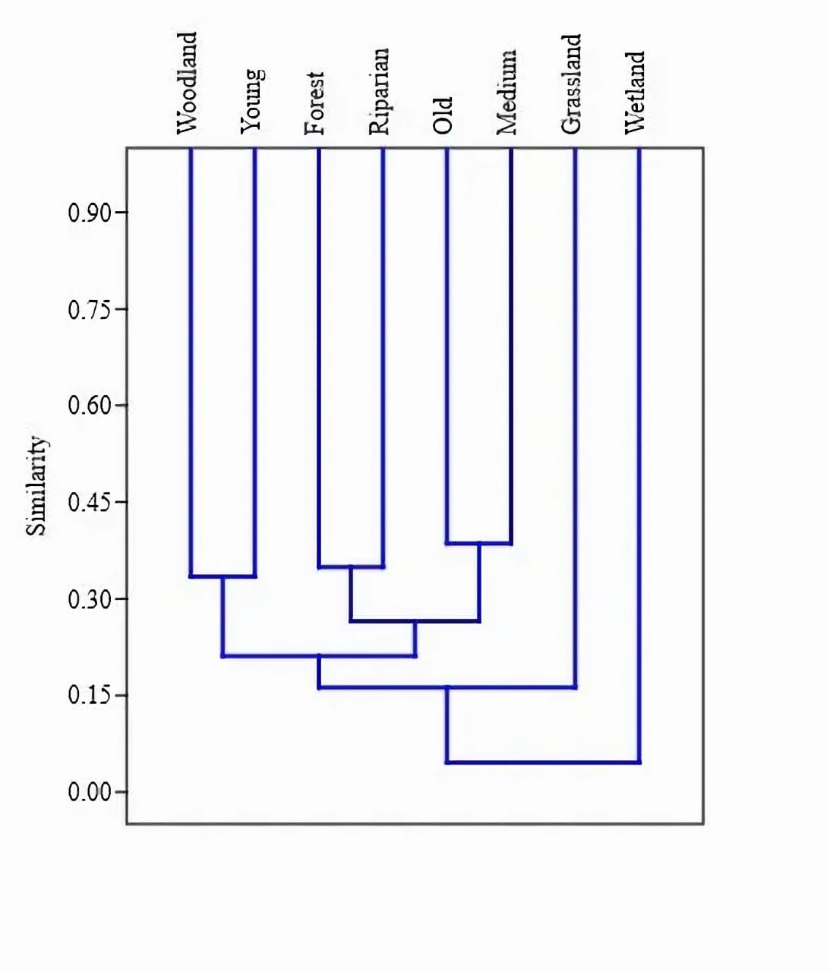
Table 7: Plant Sorensen similarity index among habitats in teak plantations and natural remnants
Habitats | Young age | Medium age | Old age | Forest | Grassland | Riparian | Wetland | Woodland
Young age
Medium age | 0.442
Old age | 0.452 | 0.457
Forest | 0.302 | 0.395 | 0.45
Grassland | 0.317 | 0.23 | 0.302 | 0.186
Riparian | 0.391 | 0.393 | 0.382 | 0.386 | 0.227
Wetland | 0.045 | 0.069 | 0.09 | 0.079 | 0.189 | 0.08
Woodland | 0.429 | 0.39 | 0.426 | 0.263 | 0.38 | 0.3 | 0.302
.
Figure 5: Bray–Curtis similarity measure of plant species composition between teak plantation and natural habitats

Plant species diversity, dominance, and evenness in natural remnants
Shannon’s diversity index indicated that natural remnants had a significant (t = 3.7663, p = 0.01) lower species diversity (H’ = 5.17) than teak plantation (H’ = 5.28). Grassland had higher plant species diversity followed by woodland, forest, riparian and the least was in wetland remnants. However, the observed variation in plant species diversity was not significantly different (p > 0.05) among the natural habitats.
Species dominance was highly recorded in wetland followed by riparian, forest, and the least was in the grassland remnants. However, within the natural remnants, Oplismenus hirtellus dominated forest, Combretum fragrans dominated grassland, Sorindeia madagascariensis dominated riparian, Phragmites australis dominated the wetland, while Diplorhynchus condylocarpon dominated the woodland. Plant species in natural habitats were more evenly distributed in grassland and the least was in wetland (Table 8).
Table 8: Plant species diversity in natural habitats
Parameters | Forest | Grassland | Riparian | Wetland | Woodland
Shannon (H’) | 4.398 | 4.455 | 4.323 | 2.617 | 4.411
Dominance (D) | 0.023 | 0.0207 | 0.0267 | 0.1111 | 0.02182
Evenness (J) | 0.561 | 0.6374 | 0.6235 | 0.4029 | 0.4267

Plant species diversity in teak plantation
Young age plantation had higher plant species diversity than the rest plantation age habitats. As teak trees matured, plant diversity was observed to decrease in medium to old age plantations respectively. However, along teak plantations, there was no notably significant variation (p > 0.05) in plant species diversity. High species dominance and lower species evenness were recorded in old age plantations. However, within the teak plantations, Brachystegia spiciformis dominated young age, Diospyros squarrosa and Uvaria welwitschii dominated the medium age while Harrisonia abyssinica dominated the old age. On the other side, Medium age plantations had high species evenness followed by young age plantations (Table 9).
Table 9: Plant species diversity, dominance, and evenness in teak plantation
Parameters | Young age | Medium age | Old age
Shannon (H’) | 4.809 | 4.738 | 4.719
Dominance (D) | 0.0119 | 0.0128 | 0.0167
Evenness (J) | 0.6417 | 0.6679 | 0.5867

DISCUSSION

Plant species composition and relative abundance
This study was conducted between December and February 2021, which is a low rainy season for the area. However, given the nature of the soil in the area, there was enough water in the soil that influenced high growth rate of the understory vegetation observed in teak plantation habitats (Pers. Observation). Along the plantation’s understory, trees and shrubs life forms were highly distributed compared to other plant life forms as for the most of natural remnants. Closeness of the natural remnants to plantation’s habitats, have influenced availability of enough non teak seed bank in the plantation through seed dispersal.
However, the distribution of plant life forms, was higher in natural remnants than teak plantation. Such superiority is contributed by presence of management activities such as slashing, burning or utilizations of weed killers in the plantation which affects growth of understory vegetation (Boreux et al. 2013). Management activities, intends to prohibit regeneration of non-teak plants especially grasses which have a competitive advantage towards other plant life forms in the plantation (Asare et al. 2020). In consequence, they affect accumulation and decomposition of organic matters on the soil and leads to lower number of plant species, families and abundance (Saha 2001, Goded et al. 2019).
In most circumstances, natural remnants are characterized with a variety of old vegetative structures that are rich in energies from decomposed organic matters and enhance growth of different plant species (Hartman et al. 2010). Allelopathy is one of the factors that is less observed in natural remnants but have proved to inhibit growth of native plant species within the teak plantation (Healey and Gara 2003). However, there is high plant species similarity observed in this study between natural remnants and teak plantation. The observation suggests that, other factors apart from it could have influenced the results.
Such factors may include the observed open canopy in young to medium age plantations which created a favorable habitat for native plant species recruitments (Lopez-Bedoya et al. 2021). According to Halpern and Spies (1995) and Loumeto and Huttel (1997) as the plantations matures, there is an increase in accumulation and decomposition of organic matters on the soil floor. That facilitates rapid growth of tree canopy and shade cover which leads to increase in plant species richness and abundance (Boch et al. 2013).
However, number of species in our study had no notable difference between young age and old age plantations. Such circumstance may have attributed by the factor that young age habitat in the case of our study, was a result of what remained after teak harvest in old age habitats. As a result, the high seed bank remained after harvest exercises, germinates rapidly to produce different species of different plant life forms as that of old age habitat. On the other side, medium age and old age habitats, had the highest species similarity in this study. Such observation is influenced by reduction in management activities as teaks matures, leading to decrease in alteration of species within the habitats.

Plant species diversity
Large part of teak plantations habitats in this study was closely surrounded with natural remnants, a reserved forest and a wetland (Pers. Observation). According, to Loumeto and Huttel (1997) closeness of the plantation to a natural forest favors floristic diversity and its development towards secondary native forest. Thus, it’s not surprisingly that teak plantation recorded higher and significantly plant species diversity than natural remnants. This observation differs from other studies conducted on teak plantations such as that of Saha (2001) and Healey and Gara (2003) that reported high plant species diversity in natural remnants than in teak plantations.
Conferring to Mligo (2018) species diversity is significantly determined by species evenness and dominance. In this study, natural remnants had high species dominance and lower species evenness than teak plantations. On top to that, plant relative abundance was relatively close in teak plantation habitats as compared to natural habitats. The higher the plant species evenness and closer its abundance, directly influences its higher plant species diversity (Moore 2013). Within the plantation, plant diversity was observed to decrease as teak plantation habitats aged. This observation is in line to those of López‐Bedoya et al. (2021).
As teaks mature, canopy closure increase while decreasing in light penetration, lower temperature and moisture on the soil floor (Asare et al. 2020). Such condition creates a poor optimal condition for seed dormancy to break and results in high species dominancy and less evenness in the understory of a plantation (Carnus et al. 2006). Despite woodland dominating the natural remnants in terms of area size, high species richness, and abundance, grassland dominated species diversity over the rest. Such results have been influenced with low species dominance and high species evenness observed in grassland over the rest habitats.

CONCLUSION AND RECOMMENDATION
This study has demonstrated that teak plantation can facilitate growth of plant species of different life forms that are more diversified as natural habitats. However, the higher diversity in plant species observed in this study has highly contributed to the closeness of this plantation to the nearest natural habitats as we observed. Natural vegetation between or around teak plantations act as a seed bank that supplies in this vast desert of teak plantation. Considering the trends deforestation in Tanzania, this study suggests the use of teak trees in other degraded areas as an alternative for biodiversity restoration. However, such exercise should consider using a form of mixed-species plantations in early stages of its development.

ACKNOWLEDGEMENTS
The authors acknowledge funding from the UK Research and Innovation’s Global Challenges Research Fund (UKRI GCRF) through the Development Corridors Partnership project (project number: ES/P011500/1)”. We are also grateful to the Kilombero Valley Teak Plantation (KVTC) management for granting us permission and for logistical support during field data collection.

REFERENCES
Asare, A., Asante, W.A., Owusu-Prempeh, N., Opuni-Frimpong, E. & Adusu, D. 2020. Comparative Analysis of Understorey Floristic Diversity and Carbon Stocks in Poorly and Intensively Managed Tectona grandis Plantations. International Journal of Forestry Research, 2020.
Bamford, A., Ferrol-Schulte, D. & Smith, H. 2010. The status of the Ruipa corridor between the Selous Game Reserve and the Udzungwa Mountains. Report to Frontier Tanzania, Dar es Salaam, Tanzania.
Bekker, C., Rance, W. & Monteuus, O. 2004. Teak in Tanzania: The Kilombero valley teak company. Bois et Fôrets des Tropiques 279: 11-21.
Bergius, M., Benjaminsen, T.A., Maganga, F. & Buhaug, H. 2020. Green economy, degradation narratives, and land-use conflicts in Tanzania. World Development, 129, 104850.
Boch, S., Prati, D., Müller, J., Socher, S., Baumbach, H., Buscot, F. & Fischer, M. 2013. High plant species richness indicates management-related disturbances rather than the conservation status of forests. Basic and Applied Ecology, 14(6), 496-505.
Bonnington, C., Weaver, D. & Fanning, E. 2009. The use of teak (Tectona grandis) plantations by large mammals in the Kilombero valley, southern Tanzania. African Journal of Ecology 47:138-145.
Boreux, V., Krishnan, S., Cheppudira, K. G. & Ghazoul, J. 2013. Impact of forest fragments on bee visits and fruit set in rain-fed and irrigated coffee agro-forests. Agriculture, ecosystems & environment, 172, 42-48.
Calvino-Cancela, M., Rubido-Bará, M. & Van Etten, E.J.B. 2012. Do eucalypt plantations provide habitat for native forest biodiversity? Forest Ecology and Management 270:153–162.
Cañadas-L, Á., Andrade-Candell, J., Domínguez-A, J.M., Molina-H, C., Schnabel-D, O., Vargas-Hernández, J.J. & Wehenkel, C. 2018. Growth and yield models for teak planted as living fences in coastal Ecuador. Forests, 9(2), 55.
Carnus, J. M., Parrotta, J., Brockerhoff, E., Arbez, M., Jactel, H., Kremer, A. & Walters, B. 2006. Planted forests and biodiversity. Journal of forestry, 104(2), 65-77.
Chittapur, B. and Patil, D.K. 2017. Ecosystem services rendered by tree-based land use systems. Indian Journal of Agricultural Sciences. 87:1419-1429.
Corlett, R.T. 2016. Ecological roles of animals in tropical forests. Tropical Forestry Handbook 503–510.
Cubbage, F., Balmelli, G., Bussoni, A., Noellemeyer, E., Pachas, A.N., Fassola, H. & Hubbard, W. 2012. Comparing silvopastoral systems and prospects in eight regions of the world. Agroforestry Systems, 86(3), 303-314.
Goded, S., Ekroos, J., Domínguez, J., Azcárate, J.G., Guitián, J.A. & Smith, H.G. 2019. Effects of eucalyptus plantations on avian and herb species richness and composition in North-West Spain. Global Ecology and Conservation, 19, e00690.
Halpern, C.B. & Spies, T.A. 1995. Plant species diversity in natural and managed forests of the Pacific Northwest. Ecological Applications, 5(4), 913-934.
Hansen, O.K., Changtragoon, S., Ponoy, B., Lopez, J., Richard, J. & Kjær, E.D. 2017. Worldwide translocation of teak—origin of landraces and present genetic base. Tree Genetics & Genomes, 13(4), 1-16.
Hartmann, H., Daoust, G. & Bigué, B. 2010. Negative or positive effects of plantation and intensive forestry on biodiversity: A matter of scale and perspective. The Forestry Chronicle, 86(3), 354-364.
Healey, S.P., & Gara, R.I. 2003. The effect of a teak (Tectona grandis) plantation on the establishment of native species in an abandoned pasture in Costa Rica. Forest Ecology and Management, 176(1-3), 497-507.
Hinde, R., Corti, G., Fanning, E. & Jenkins, R.K.B. (2001b). Anurans in the Kilombero valley, Tanzania: comparison between miombo woodland, evergreen forest and teak plantations. African Journal of Herpetology 50: 35–39.
Hinde, R.J., Corti, G.R., Fanning E. & Jenkins, R.K.B. (2001a). Large mammals in miombo woodland, evergreen forest and a young teak (Tectona grandis) plantation in the Kilombero valley, Tanzania. African Journal of Ecology 39 (3):318–321.
Höllermann, B., Näschen, K., Tibanyendela, N., Kwesiga, J. & Evers, M. 2021. Dynamics of Human–Water Interactions in the Kilombero Valley, Tanzania: Insights from Farmers’ Aspirations and Decisions in an Uncertain Environment. The European Journal of Development Research, 33(4), 980-999.
Horak, J., Brestovanská, T., Mladenović, S., Kout, J., Bogusch, P., Halda, J.P. & Zasadil, P. 2019. Green desert? Biodiversity patterns in forest plantations. Forest Ecology and Management 433, 343–348.
Huang, G.H., Liang, K.N., Zhou, Z.Z., Xu, J.M. & Ma, H.M. 2015. Genetic variation and origin of teak (Tectona grandis L.f.) native and introduced provenances. Silvae Genetica 64 (1-6), 33–46.
Jenkins, R.K.B., Roettcher, K. & Corti, G. 2003. The influence of stand age on wildlife habitat use in exotic teak tree, Tectona grandis plantations. Biodivers, Conserv 12:975–990.
Johansson, E.L. & Isgren, E. 2017. Local perceptions of land-use change: using participatory art to reveal direct and indirect socioenvironmental effects of land acquisitions in Kilombero Valley, Tanzania. Ecology and Society, 22(1).
Kaewkrom, P., Gajaseni, J., Jordan, C.F. & Gajaseni, N. 2005. Floristic regeneration in five types of teak plantations in Thailand. Forest Ecology and Management, 210(1-3), 351-361.
Kanowski, J., Catterall, C.P. & Wardell-Johnson, G.W. 2005. Consequences of broad scale timber plantations for biodiversity in cleared rainforest landscapes of tropical and subtropical Australia. Forest Ecology and Management 208(1-3), 359–372.
Koonkhunthod, N., Sakurai, K. & Tanaka, S. 2007. Composition and diversity of woody regeneration in a 37-year-old teak (Tectona grandis L.) plantation in Northern Thailand. Forest ecology and management, 247(1-3), 246-254.
Kremer, K.N. & Bauhus, J. 2020. Drivers of native species regeneration in the process of restoring natural forests from mono‐specific, even‐aged tree plantations: a quantitative review. Restoration Ecology, 28(5), 1074-1086.
Lindell C.A, & Thurston, G.M. 2013. Bird pollinator visitation is equivalent in island and plantation planting designs in tropical forest restoration sites. Sustainability 5:1177–1187.
López‐Bedoya, P.A., Magura, T., Edwards, F.A., Edwards, D.P., Rey‐Benayas, J.M., Lövei, G.L. & Noriega, J.A. 2021. What level of native beetle diversity can be supported by forestry plantations? A global synthesis. Insect Conservation and Diversity, 14(6), 736-747.
Loumeto, J.J. & Huttel, C. 1997. Understory vegetation in fast-growing tree plantations on savanna soils in Congo. Forest Ecology and Management, 99(1-2), 65-81.
Lowe, A. & Volkaerts, H. 2013. The evolutionary and plantation origin of teak. Jalan Jati, 186-9.
Malende, Y.H. & Temu, A.B. 1990. Site-index curves and volume growth of teak (Tectona grandis) at Mtibwa, Tanzania. Forest ecology and management, 31(1-2), 91-99.
Mligo, C. 2018. Application of regression model to identify a parameter that best defines species diversity in the coastal forests of Tanzania. Tanzania Journal of Science, 44(3), 31-45.
Msofe, N.K., Sheng, L. & Lyimo, J. 2019. Land use change trends and their driving forces in the Kilombero valley floodplain, southeastern Tanzania. Sustainability 11: 505.
Ollerton, J., Winfree, R. & Tarrant, S. 2011. How many flowering plants are pollinated by animals? Oikos 120: 321-326.
Palanisamy, K., Hegde, M. and Yi, J. 2009. Teak (Tectona grandis Linn. f.): A Renowned Commercial Timber Species. Journal of Forest Science Vol. 25, No. 1, pp. 1-24.
Saha, S. 2001. Vegetation composition and structure of Tectona grandis (teak, Family Verbanaceae) plantations and dry deciduous forests in central India. Forest ecology and management, 148(1-3), 159-167.
Verhaegen, D., Fofana, I.J., Logossa, Z.A. & Ofori, D. 2010. What is the genetic origin of teak (Tectona grandis L.) introduced in Africa and in Indonesia? Tree Genetics and Genomes, 6(5), 717–733.

