**FIGURES**

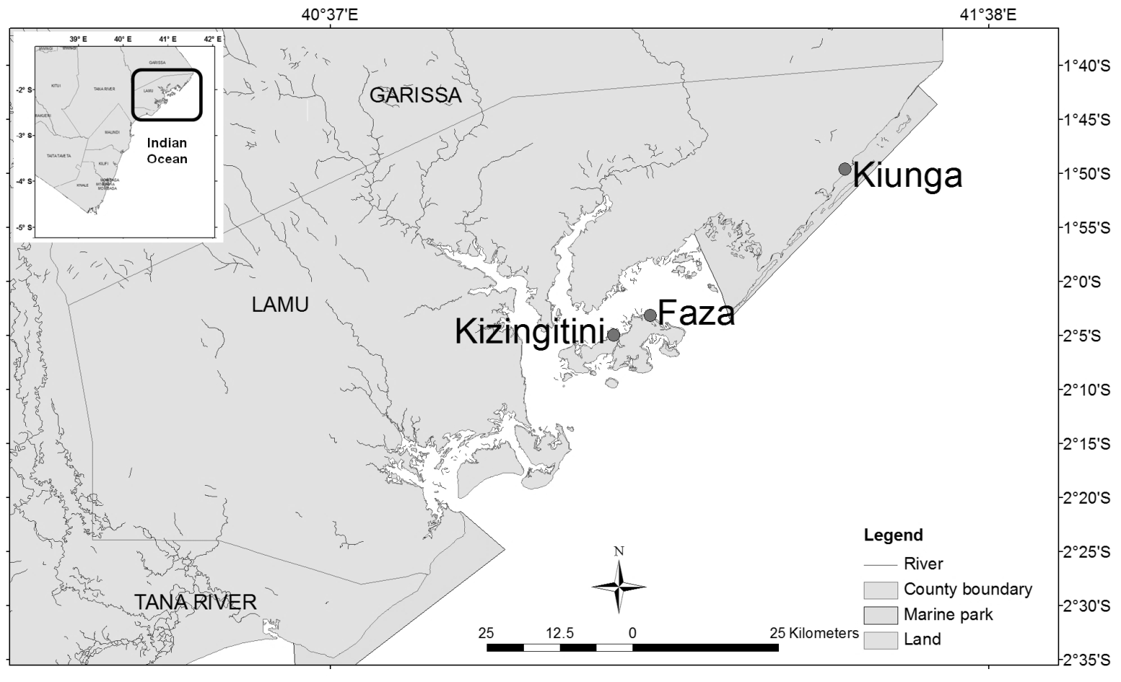

**Fig. 1.** A map of the north coast Kenya, with dark filled circles showing the sampling sites in Lamu.



**Total length (cm)**

N=187

N=164

N=249

**Frequency (%)**

**Fig. 2.** Comparative size frequency graphs for 1.0 inch codend mesh size of the three dominant species.Dotted lines designated the size of *L*mat.



**Total length (cm)**

**Frequency (%)**

N=158

N=49

N=64

**Fig. 3.** Comparative size frequency graphs for 1.5 inches codend mesh size of the three dominant species.Dotted lines designated the size of *L*mat.

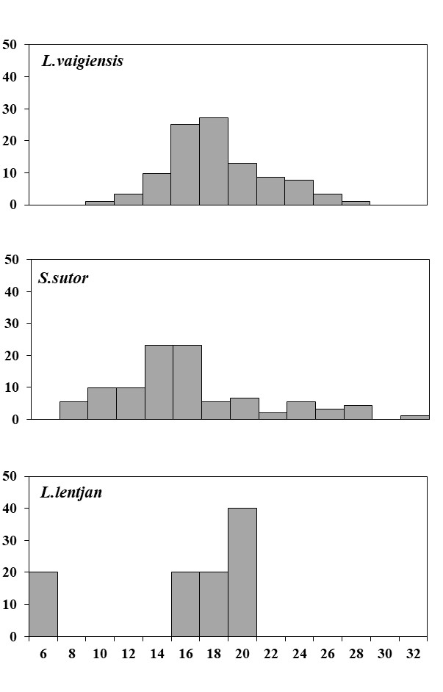

**Total length (cm)**

N=5

N=92

N=92

**Frequency (%)**

**Fig. 4.** Comparative size frequency graphs for 1.75 inches codend mesh size of the three dominant species.Dotted lines designated the size of *L*mat.

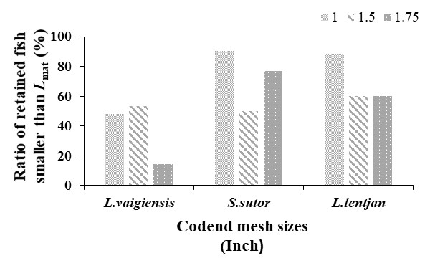

**Fig. 5.** Ratios (%) of the three dominantspecies<*L*mat retained by different codend mesh sizes.