**TABLES**

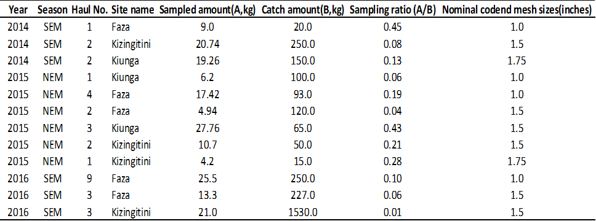**Table 1.** Summary of the field survey

**Table 2.** Species composition by counts (%) by codend mesh sizes

**Table 3.** Species composition by weight (%) by codend mesh sizes

