Participatory assessment of priority fishery profiles for an overfished urban inshore seascape in Kenya
¹Johnstone Omuhaya Omukoto*, ² Horace Owiti, ² Victor A. Mwakha, ³Cosmas Nzaka Munga, ⁴Andrew Wekesa Wamukota
Supplementary material
¹Marine and Coastal Fisheries Research Department, Kenya Marine and Fisheries Research Institute, P.O. Box 81651 Mombasa, Kenya. Email: jomukoto@gmail.com
²Socio-Economic Research Department, Kenya Marine and Fisheries Research Institute, P.O. Box 81651 Mombasa, Kenya. Email: owitihorace@yahoo.com ; vmwakha@gmail.com
³Department of Environment and Health Sciences, Marine Sciences Section, Technical University of Mombasa P.O. Box 90420 – 80100, Mombasa, Kenya. Email: cosmasnke2001@yahoo.com
⁴Department of Environmental Studies (Community Development), School of Environmental and Earth sciences, Pwani University, P.O. Box 195-80108, Kilifi, Kenya. Email: awamukota@gmail.com

* Corresponding author email: jomukoto@gmail.com

Appendix 1. Modified Delphi questionnaire tool with a 5-point Likert scale
The following criterion based on a scale of 1 – 5 is proposed for selecting priority fisheries profiles for the Nyali-Mtwapa Seascape based on stakeholders’ consultation:

Criteria 1: Community Participation [Level are lowest (1) to highest (5)]
 |  | Fishery types
No | Questions
 | Are indigenous the main fishers involved in the fishery?
 | Are the fish species eaten by the indigenous communities?
 | Are women involved in the fishery?
 | Are the youth involved in the fishery?

Criteria 2: Income [Level are lowest (1) to highest (5)]
 |  | Fishery types
No | Questions
 | Does the fishery provide adequate income to the fishers?
 | Does the fishery provide adequate income to fish traders?
 | Is the fish traded beyond the local area?
 | Does trading fish outside the fishing area give better income?

Criteria 3: Production and Catch [Level are lowest (1) to highest (5)]
 |  | Fishery types
No | Questions
 | Do the fishers get enough catch on a daily basis?
 | Have catches declined in the past 10 years?
 | Are catches expected to be stable in the next 10 years?

Criteria 4: Co-Management [Level are lowest (1) to highest (5)]
 |  | Fishery types
No | Questions
 | Is the BMU involved in managing the fishery?
 | Does the BMU provide any services at the landing site?
 | Is the BMU involved in marketing of the fish?
 | Does the BMU have infrastructure for marketing?
 | Are there any illegalities in the fishery?
 | Does the BMU participate in controlling these illegalities?
 | Is the BMU effective in implementing regulations?
 | Does the BMU collaborate with other partners?
 | Are there clear management measures for the fishery?
 | Are legislations and regulations known to the BMU Assembly?

Criteria 5: Ecosystem Impacts [Level are lowest (1) to highest (5)]
 |  | Fishery types
No | Questions
 | What is the intensity of fishing in the coral reefs?
 | Does the fishing interfere with the corals?
 | What is the intensity of fishing in the sea grass beds?
 | Does the fishing interfere with the sea grasses?
 | Does fishing take place in the estuaries?
 | Does the fishing interfere with the estuarine ecosystem?
 | Does the fishery catch any juveniles of the targeted species?
 | Does the fishery catch juveniles of non-targeted species?
 | Does the fishery catch sea turtles?
 | Does the fishery catch dolphins and dugongs?
 | Does the fishery catch sharks?
 | Does the fishery catch rays and skates?

Criteria 6: Types of Gears Used [Level are lowest (1) to highest (5)]
 |  | Fishery types
No | Questions
 | Are the gears used in the fishery available locally?
 | Are the gears used in the fishery affordable? (probe for prices)
 | Are the gears used in the fishery legally acceptable?
 | Are the gears used in the fishery left in the sea or carried back to the shore after fishing?
 | Are the gears easy to repair?
 | Do the gears last for a long time? (Durability)
 | Are the gears frequently lost at sea?

Criteria 7: Fishing Crafts Used [Level are lowest (1) to highest (5)]
 |  | Fishery types
No | Questions
 | Are the fishing crafts used in the fishery constructed locally?
 | Are the fishing crafts used in the fishery affordable? (Probe cost)
 | Are the fishing crafts used in the fishery considered seaworthy?
 | Are the fishing crafts used in the fishery easy to maintain/repair?
 | Are the fishing crafts used in the fishery made of timber?
 | Are the fishing crafts used in the fishery made of fibreglass?
 | Are the fishing crafts used in the fishery made of metal?
 | Are the fishing crafts propelled by paddles?
 | Are the fishing crafts propelled by sail?
 | Are the fishing crafts propelled by outboard engines?
 | Are the fishing crafts propelled by inboard engines?

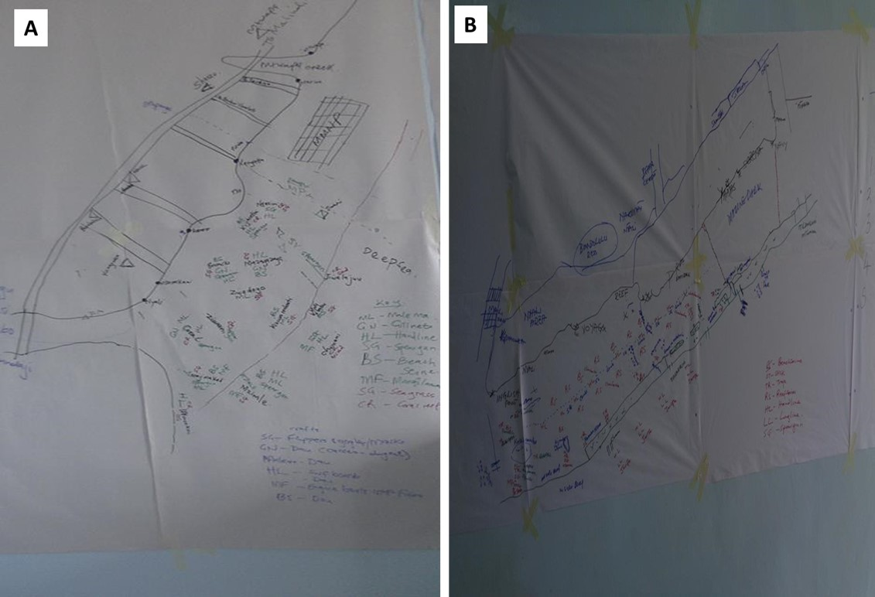
Appendix 2. Community priority fisheries resource maps for A – Nyali and B – Reef landing sites along coastal Kenya

Appendix 3. Community priority fisheries resource maps for C – Bamburi and D – Marina/Mtwapa landing sites along coastal Kenya
